Install the Python with the help of the Command Prompt

Part 1: Install Python on Window
Python is the programming languages and interpreter used to execute python program. Install the official Python released first, then verify that window we find it.
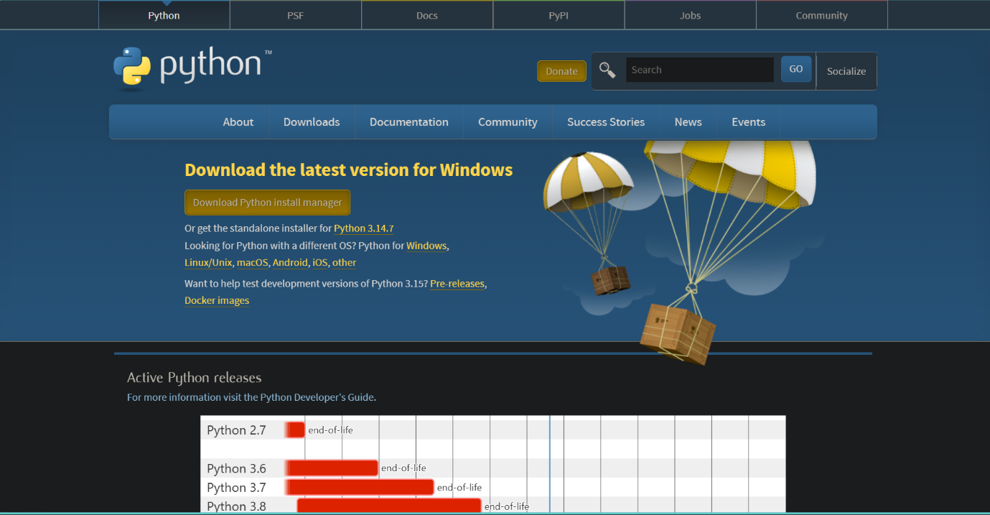
Step 1: Download the python
Click on Download Python 3.x.x. latest version.
Open the official Python websites and go to Download section. Download the latest stable Python 3 release for window.
- Official websites http://www.python.org/
- Choose the window installer appropriate for your computer, 64-bits is standard for the most modern window laptops.
- Run the Installer file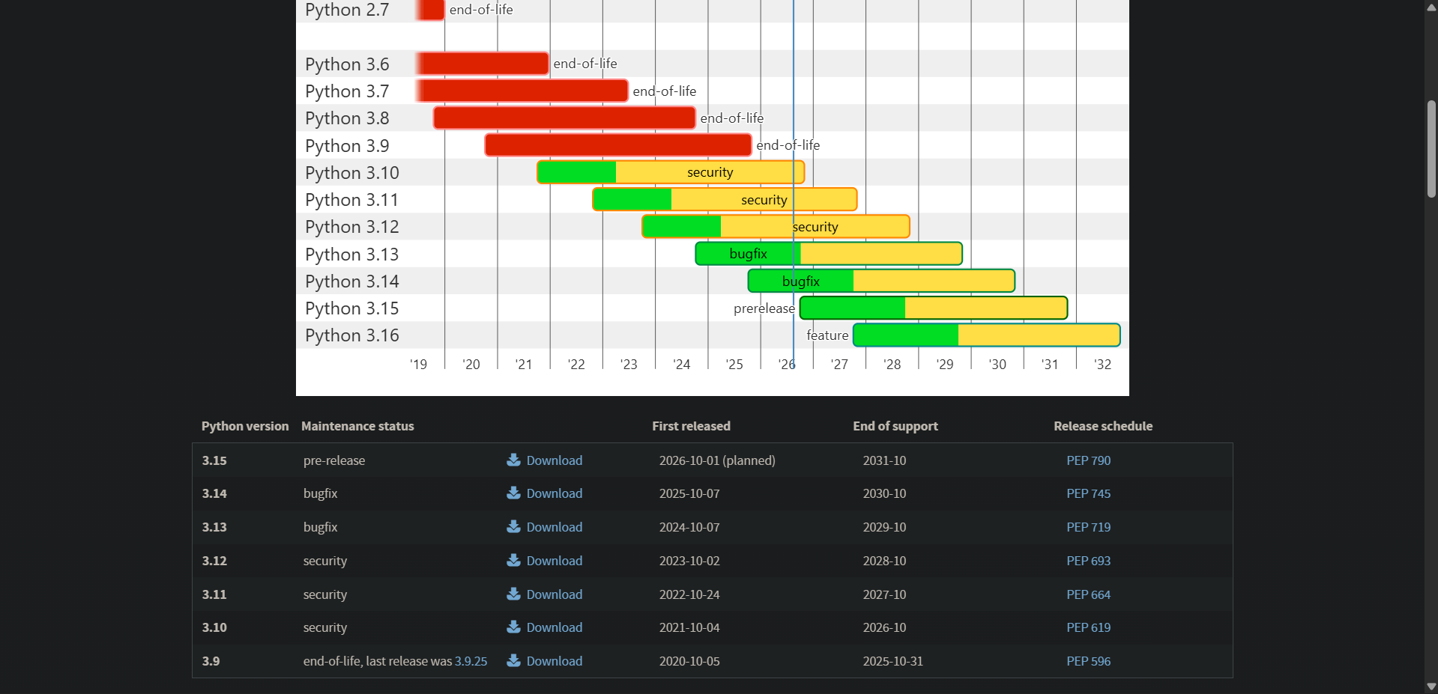
Here we have done the pthyon setup completely Download.

Step 2: Start the python installer
Open the download installer file. The File name normally look similar to python – 3.x.x and 64 exe.
- Look near the bottom of th e installer for the PATH option.

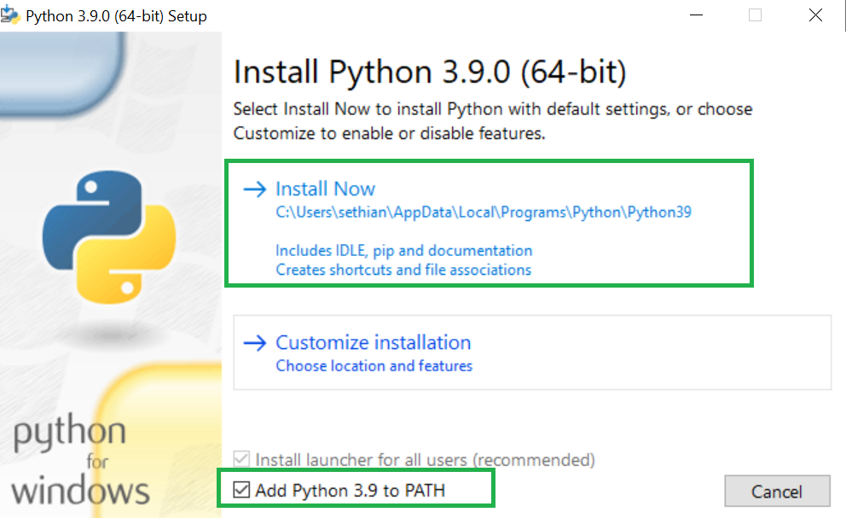
Check “Add python.exe to PATH”. Then click “Install Now.”

Step 3:- Enable Add python to PATH
Before selecting Install Now, Check the option labelled “Add python.exe to PATH”. This is one of the most important configuration, step because it let you run Python from command promopt or PowerShell.
Important: Make sure the PATH option is checked before continuing.

Step-4 :- Install Python
Click “Install Now” and wait while window installs python and its standard components.
- Wait until the setup report that the installation was sucessfully.
- Click close when the install finish.

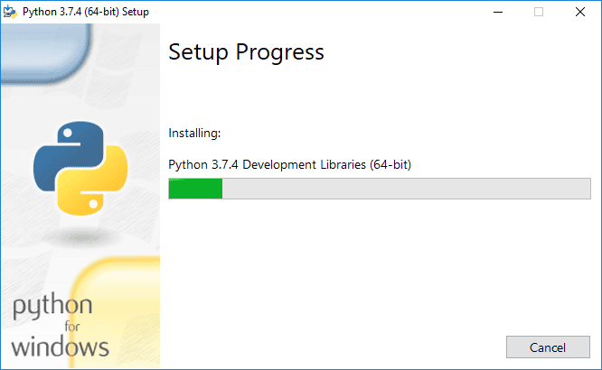wait for the installation to complete.

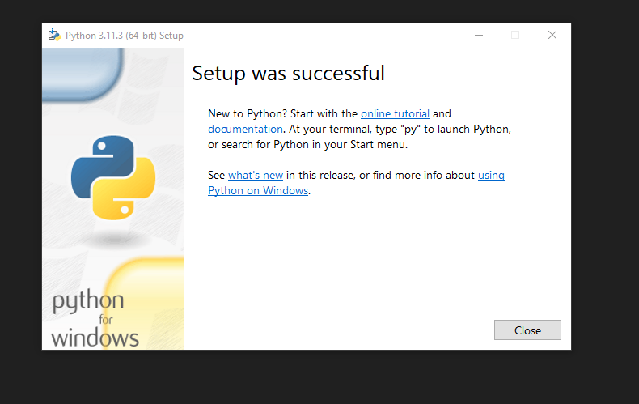Click “Close” after installation is complete.

Step 5:- Verify the python by command promopt.

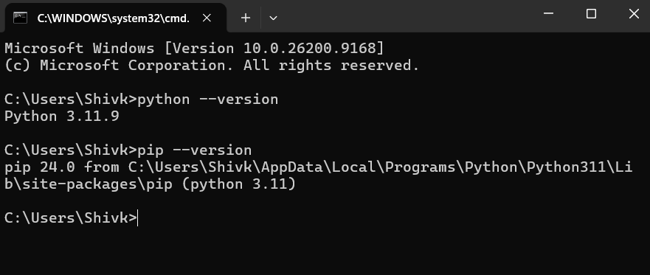
Verify the python installation.

Part 2 :- Install the VS code
VS code is the ligthwieght OS coder editor that provide the conviented enviroment to write, run and debugging the code.

Step 6:- Download the VS code
Open the offical VS code websites and downlaod the window install.
- Official websites :- https://code.visualstudio.com/
- Select the window download and run the installer after the download complete.
- Download VS code.
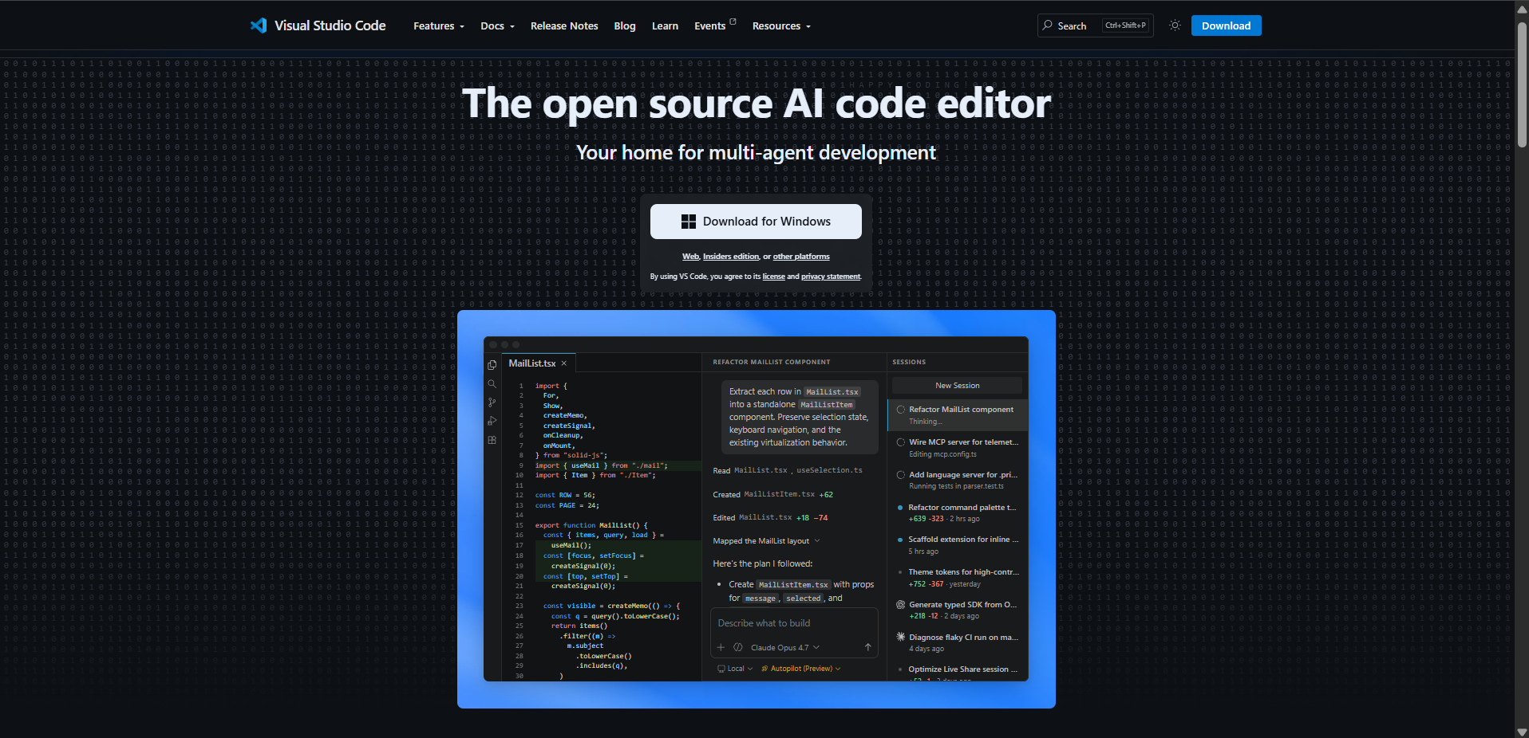
Step 7 : Install the VS code:
- Accept the License agreement.
- Choose the installation location or keep the default.
- Cotinous through the stepup wizard and keep the default.
- Lanuch Vs code after installation.
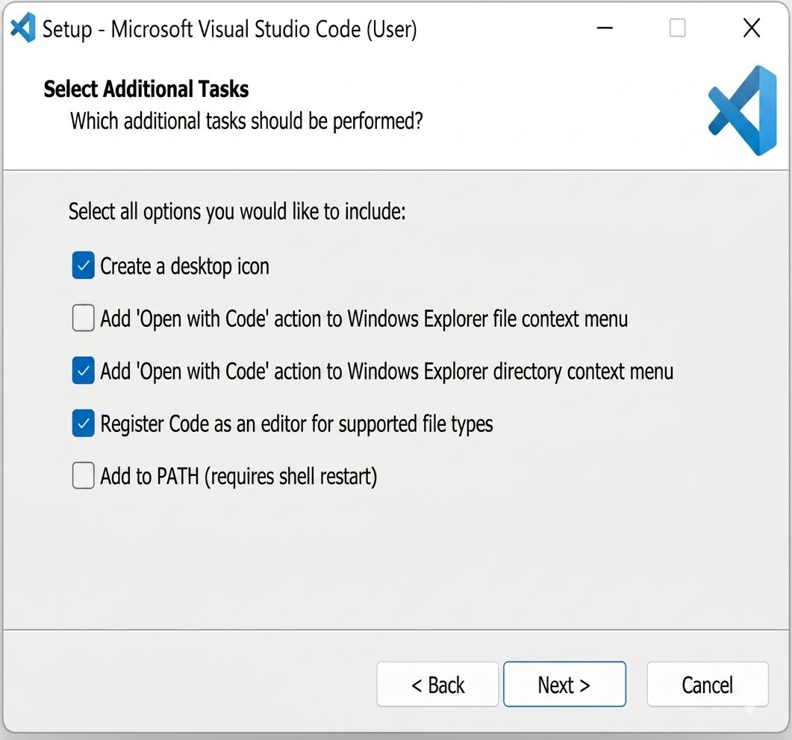
Run the installer and follow the setup wizard.

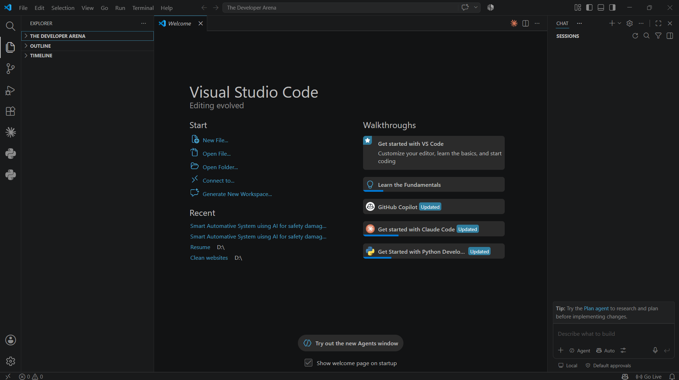

Part 3 :- Configuration Python VS Code

Step 8: Install the python extesion
Inside VS code:
- Open the extension folder.
- Search for the python extension publish by Microsoft.
- The extension provide Pyton Languages support, dubging, IntelliSense, and Interpreter.
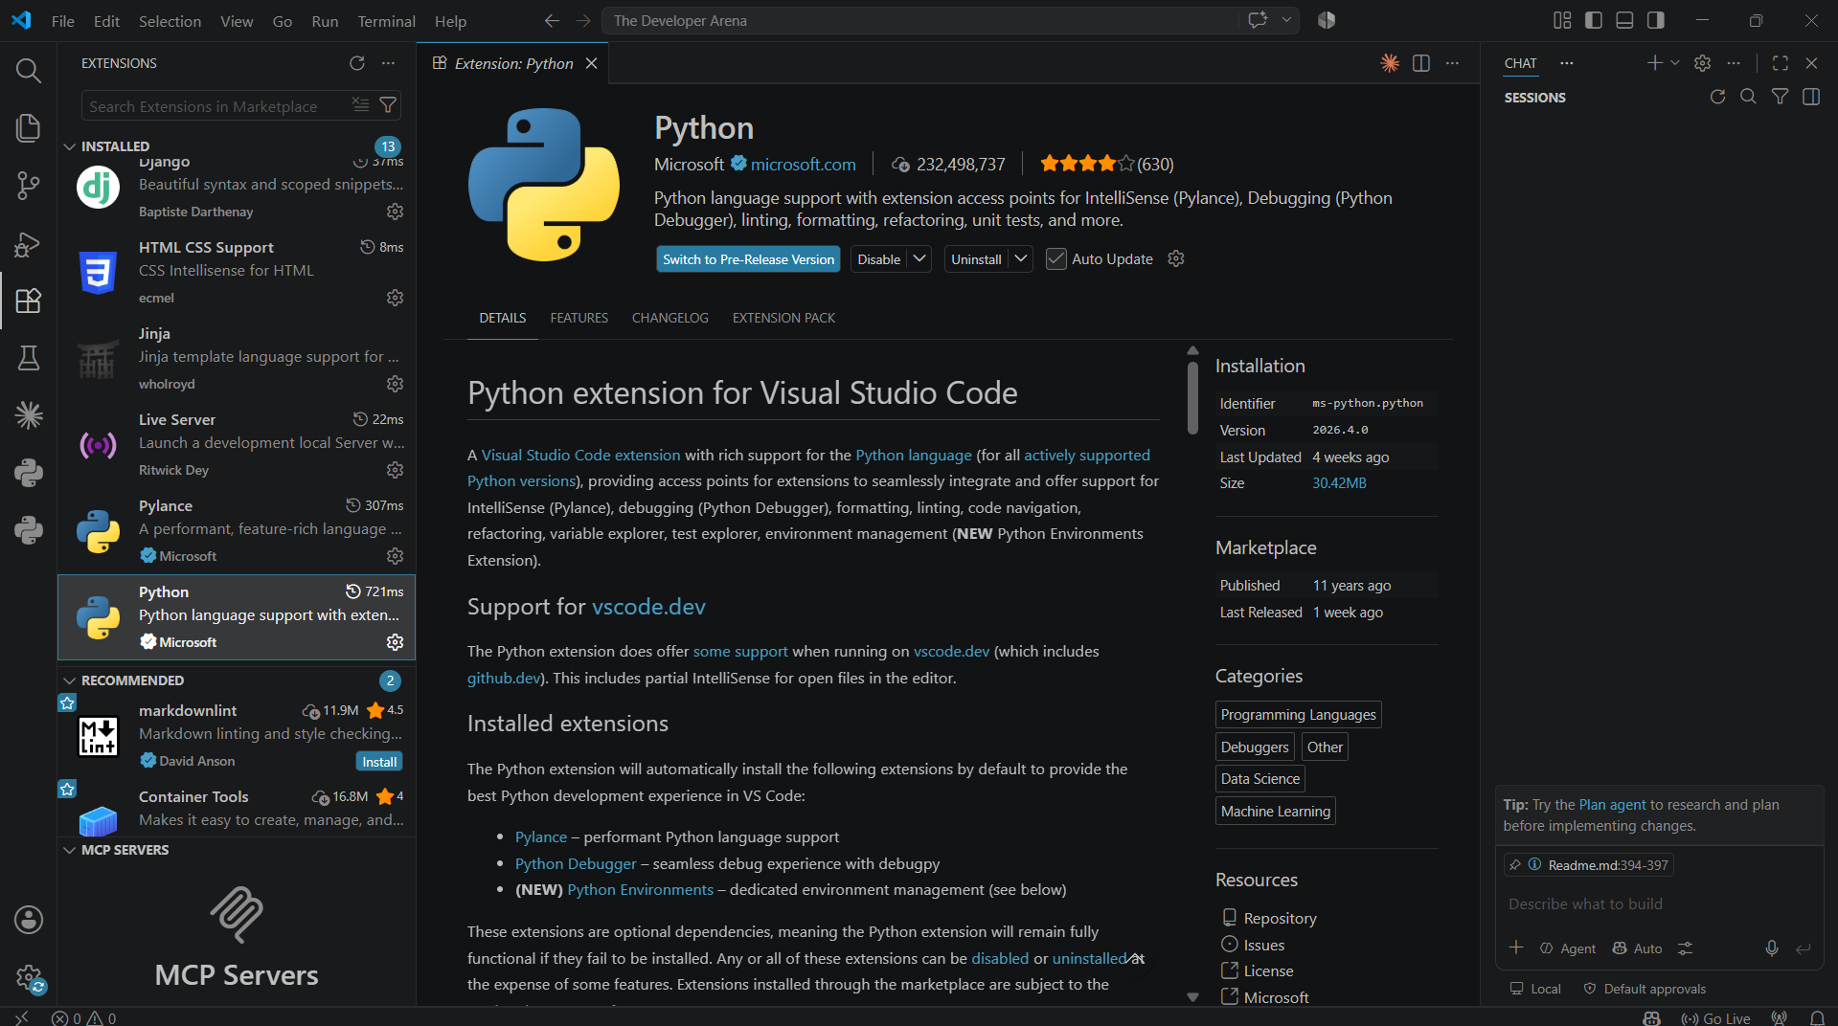
Go the extension search “Python and Install”

Part 4 :- Create and Run Your First Python Program

Step 9:- Create a Python File
In the VS Code explorer, create a new file named:
- Open or Create folder “Open Folder” and Select create your project folder.

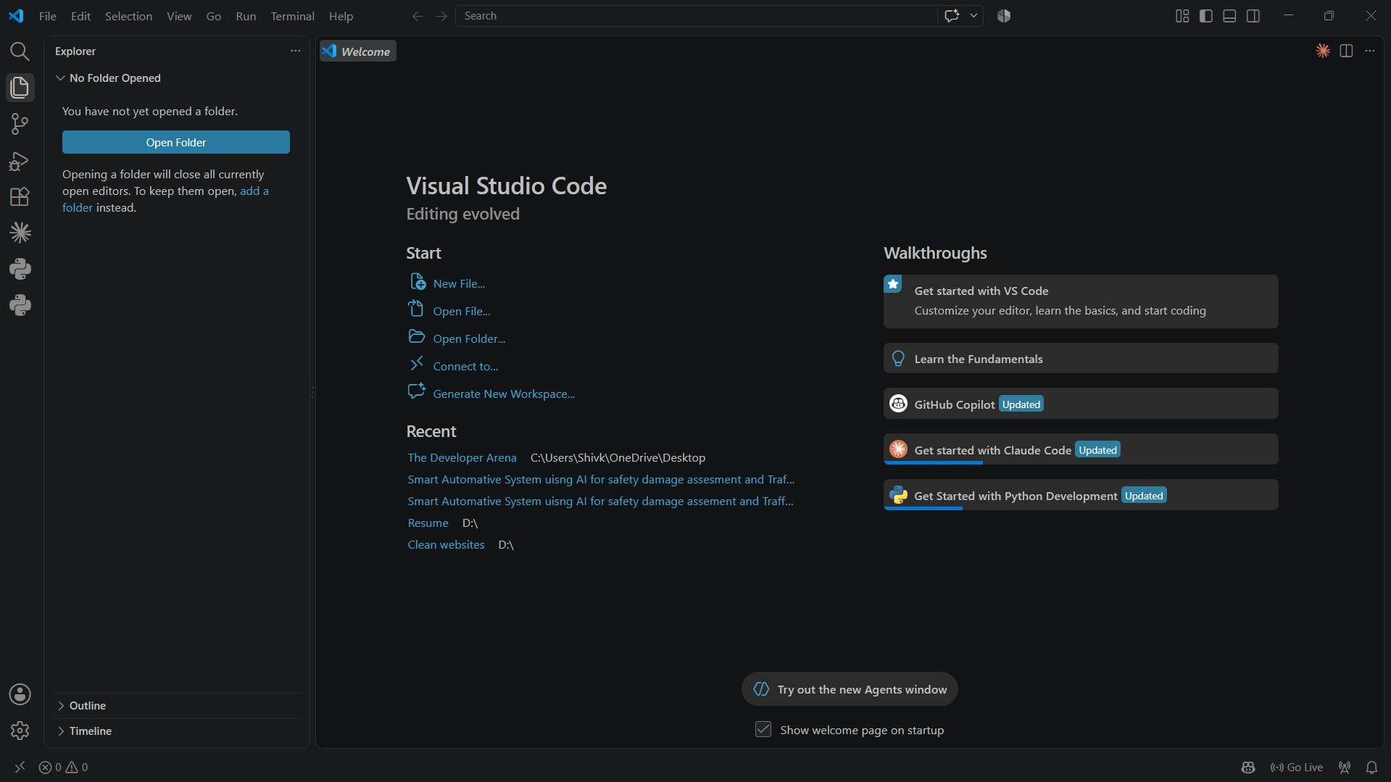

Step 10:-Select the python interpreter
VS code needs to know which Python installation should execute you code :-
- Press crtl+shift +P
- Search for: Python: Select Interpreter
- Select the Python version you installed.
- If you later create a virtual enviroment, select the interpreter inside that enviroment.
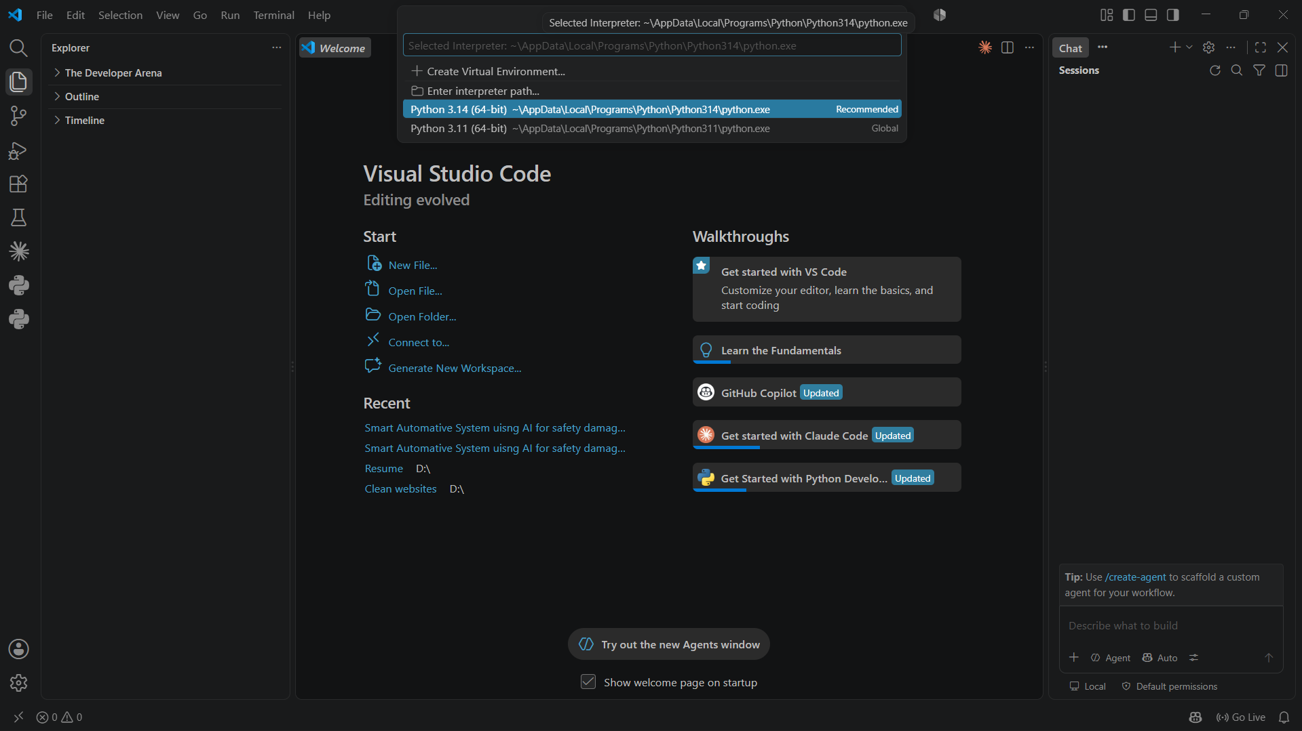
Choose Python version you install

Step 10 :- Write the Program
Enter the following code:
Print (“Hello, Python !”)
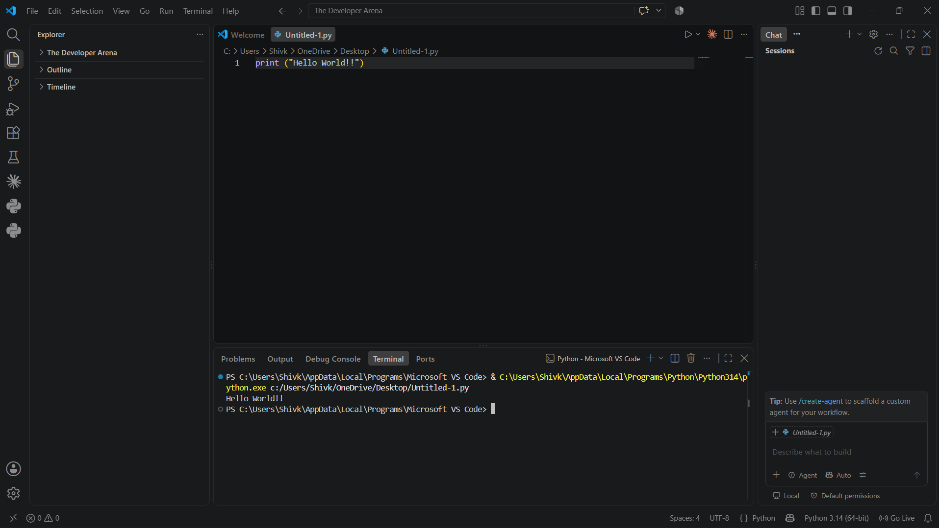
You python program ran successfully.

Step 12:- Run the program
Save the file and run it using the Run Python file buttom in VS code, or open the terminal and exceute the following command:-
Python hello.py
Except Output:
Hello, Python !

Part – 5 : Use the Vs code Terminal

The intergrate terminal let you run Python command without leaving VS code :
- Open Terminal > New Terminal.
- Run python –version to verify the interpreter.
- Run python hello.py to execute a Python file.
- Use the pip install Python packages.

Part-6 : Recommended :Create a Virtual Enviroment

A virtual enviroment create an isolated Python enviroment for a project. The is recommended for project that use external librabries.

Step 13: Create the virtual enviroment
Python -m venv venv

Step 14: Activate the virtual enviroment on windows
Venv/Scripts/activate
When activation succeds, the terminal normally show(venv) before the command promopt.

Step 15: Install packages:
For example :-
Python -m pip install numpy pandas matplotlib
Check installed packages with:
pip list

Step 16:- Deactivate the enviroment
Deactivate

Command | Purpose
Python –version | Check the python version
Pip –version | Check the pip version
Python -file name.py | Run python program
Python -m venv venv | Create the virtual enviroment
activate | Activate the virtual enviroment
deactivate | Deactivate the virtual enviroment
Python -m pip install package | Install the python packages
Pip list | Display install packages

Final Setup Checklist
- Python is installed an window laptop.
- The “Add python.exe to PATH” option was enable during installation.
- Python –version works in command Promopt or VS Code or the VS code terminal.
- Pip –version works.
- VS code is installed.
- The Microsoft python extension is installed.
- The corrected python interpreter is selected in VS code.
- A .py file can be created and excuted.
- A virtual enviroment can be created and activated.

What to learn Next ?
After completion the setup, begin with Python fundamental in this order:-
- Hello World and how Python code executes.
- Variable and data types.
- String and basic mathematical operations.
- Numbers and basic mathematical operations.
- List and accessing list element.
- Conditional Statement (if, elif, else).
- Loops (for and while).
- Functions, File Handling, Dictionaries and sets.
- Modules and package.
- Basic Object-Orientend programming.

